**Performance Test Report**

**For**

**Execution of**

**Kernel OTPManager – 225 users**

Date: 08 June 2020

Author: Gaurav Sharan

**Summary**

This report presents the observations and findings of the load test conducted for a load of 225 users on kernel OTP-manager services.

The objective of this load test was to observe and record behavior of the application when user load is increased from 50 to 225.

Below are the scenario details:

|  |  |
| --- | --- |
| **Script/Report Name** | Kernel OTP Manager Service |
| **Run Date** | 08-June-2020 |
| **Period** | 05:32:31 UTC to 06:49:43 UTC |
| **Number of concurrent users** | 50 to 225 |
| **Ramp up** | 01 user per second |
| **Run Duration** | --- |
| **Ramp down** | NA |

The transaction response times observed were as below:

|  |  |  |  |  |  |  |  |
| --- | --- | --- | --- | --- | --- | --- | --- |
| **Label** | **# Samples** | **Average(ms)** | **90% Line(ms)** | **Min(ms)** | **Max(ms)** | **Error %** | **Throughput** |
| TR_Generate_OTP | 452460 | 835 | 1020 | 7 | 91092 | 76.35% | 97.79455 |
| TR_validate_OTP | 106995 | 1591 | 2656 | 9 | 60253 | 0.43% | 29.40224 |
| TOTAL | 559455 | 979 | 1378 | 7 | 91092 | 61.83% | 120.9204 |

**Performance Test Execution Details**

We have executed JMeter script for kernel OTP manager service, which has transactions mentioned in the above table.

Average response time of the APIs is 979 ms with error rate 61 %, error appeared for generate OTP request at a user load of 225 users when most of the APIs failed with 503 error. OPT manager pod has crashed.

**Response Time and TPS Graph:**

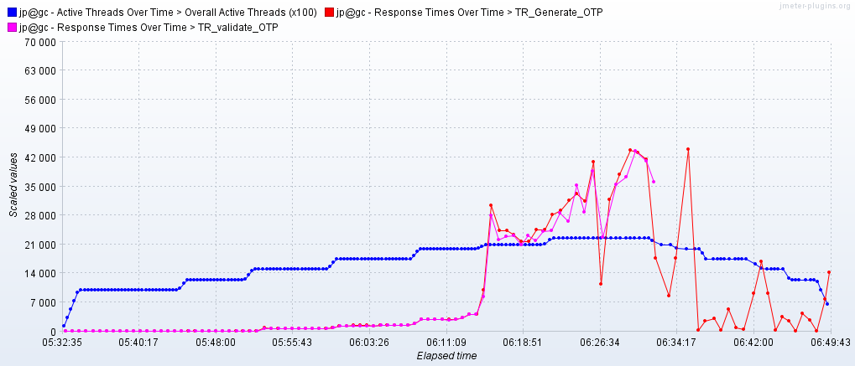

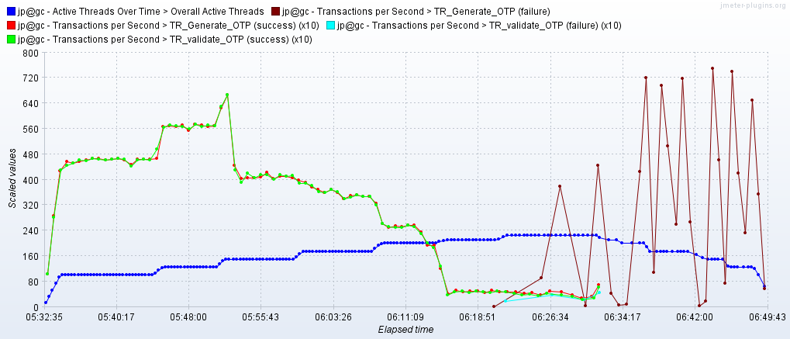

As seen in the response time graph, response time of the APIs is approx 100 ms when 125 users are active, it is 1.5 second for 175 users and reaches 20 seconds when 200 users are active. Application crashes when user level reaches 225.

Throughput (TPS) of the APIs reaches 56 when 125 users are active and comes down for higher number of uses. It finally crashes at 225 user load.